DO YOU HAVE ANY QUESTIONS?
Please do not hezitate to ask!
Pastor in EELC Saku St. Thomas congregation:
Magne Mölster, magne.molster@eelk.ee, tlf. +372 5919 7802
Leader of the Foundation of Saku church building and dean:
Jüri Vallsalu, juri.vallsalu@eelk.ee, tlf. +372 5645 3660 (in German)
Chairman of the bord:
Juhan Talpsepp, juhan.talpsepp@gmail.com, tlf. +372 50 312 98
Webpage: Saku.eelk.ee/kirik
BANKING INFORMATION
Name of the receiver: Saku Kiriku Ehitus SA
IBAN: EE95 2200221056504915
SWIFT/BIC: HABAEE2X
Bank’s address: Swedbank AS, Liivalaia 8, 15040 Tallinn.
The EELC archbishop Urmas Viilma is the patron of the Saku church building.
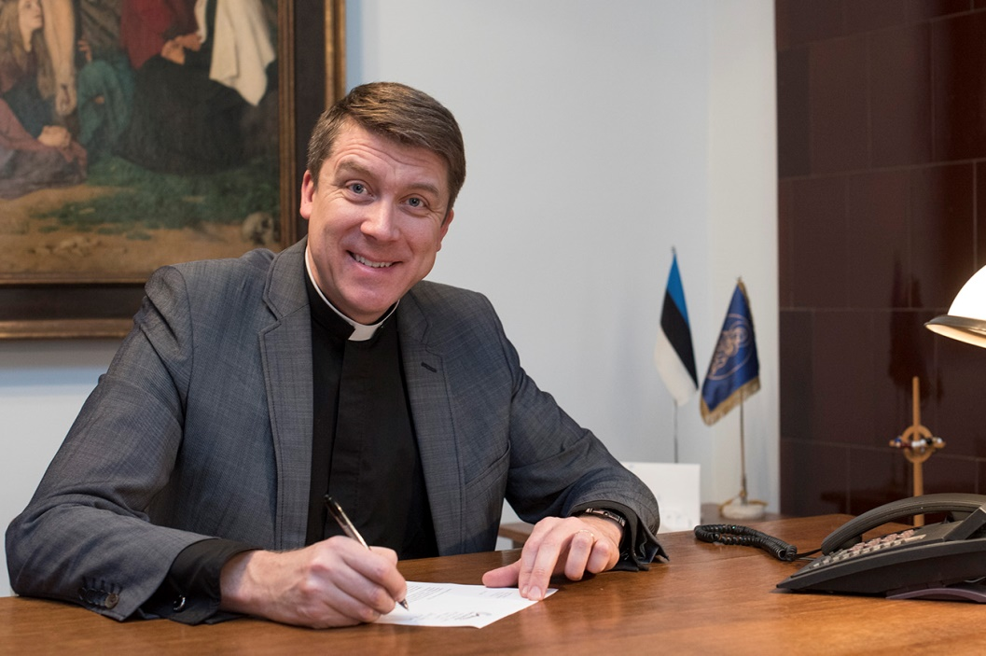
SEE YOU IN CHURCH!

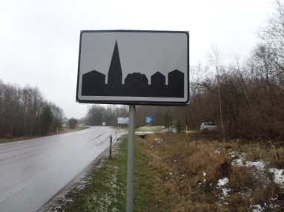
Let’s build a church in Saku!
Saku is one of the suburbs of the Estonian capital, Tallinn. When you drive into Saku, you will see this traffic sign. But a sacral church building you cannot find here, although there are app. 9300 inhabitants in the municipality of Saku. The young and small, but also growing, lutheran congregation in Saku strongly feels the need for a church building. We are asking individuals as well as companies and organizations to become Saku church supporters!
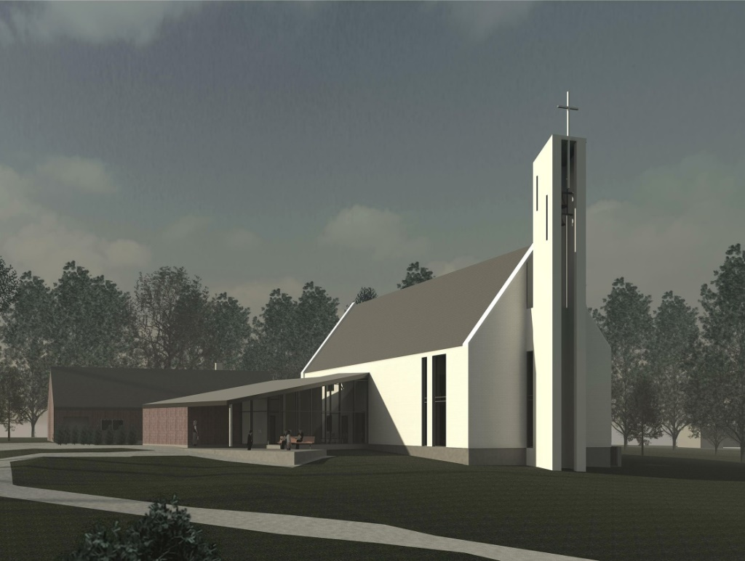
Saku has been a growing centre for decades, a place with many young families. Christian (Lutheran) ministry has been going on here since 1994, but the congregation was established in 2013.
Saku St. Thomas Congregation belongs to the Estonian Evangelical Lutheran Church (EELC), traditionally (before the communist time) the national church of Estonia. For the time being, the congregation is renting an old Moravian prayer house for it’s services and other work.
The prayer house is cosy, but unfortunately, more than 45 people can hardly have a seat here, as it is so small. For certain purposes, it is not fitting (i.e. funerals, weddings, activities for small children and the handicapped).
For more than a decade eager minds have worked with the idea of building a church in Saku, as the place does not have any other sacral buildings. Finally, all the details are set and building permissions given. But indeed we need a lot of prayers and support, as we cannot expect any financial support from the state or municipality.
A MODERN, BUT SACRAL CHURCH
In the planning process the congregation has been blessed with a good cooperation with Juhan Põld, an architect, who is also a member of our mother-congregation, Hageri. He has put in a lot of effort to draw a church that is at the same time a sacral and a practical building for a congregation with wide needs.
FACTS ABOUT THE SAKU CHURCH
* Net area: 643 m2. In the main building there are also rooms in the basement and half of a second floor. The annex will be 143 m2.
* Seats: App. 100 in the sanctuary. If the sliding door into the sitting-room is opened, there could be up to 200 seats. In addition there will be some seats available in the gallery.
* Estimated price: The first stage (the church part, offices, paths and roads, landscape) will cost app. 750 000 euros. The second stage (additional building with an apartment, garage etc.) will cost app. 200 000 euros. All together: App. 950 000 euros.
* Architects: Juhan Põld and Kristiina Renter, Kalle Rõõmus architect office.
* Use of the church: Services, weddings, funerals, children’s and youth work, prayer groups, offices, meetings, concerts, diaconal activities etc. The sitting-room and children rooms can be rented out to children’s birthdays etc. The church room will offer musicians the best acoustic that is to be found in Saku.
1. main floor plan:
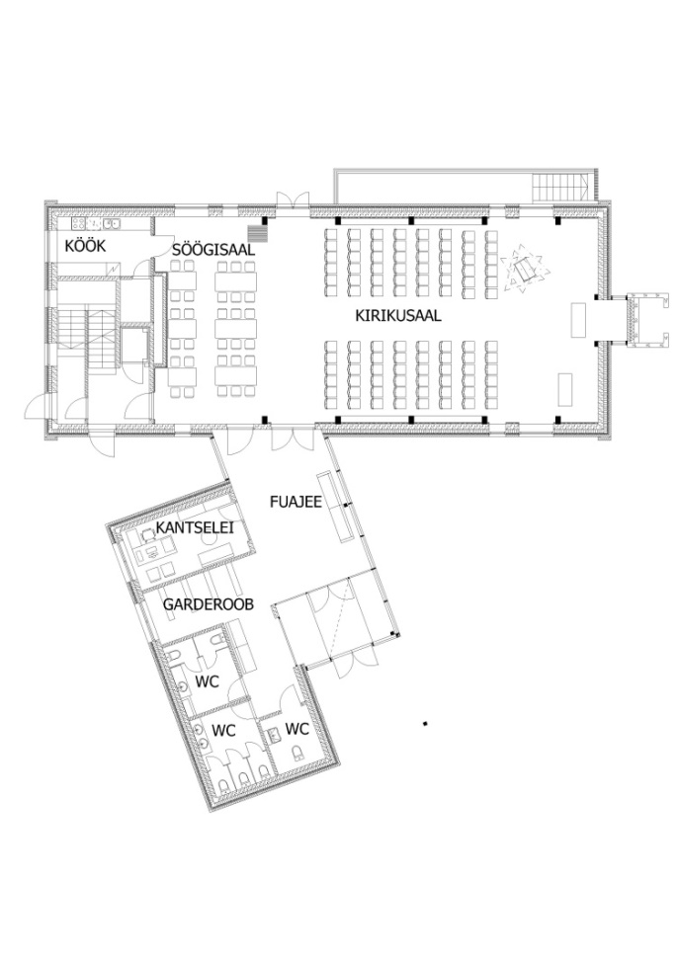
WHO ELSE IS SUPPORTING THE SAKU CHURCH BUILDING?
Lohja and Liperi friendship congregations and Christian Businessmen Association (Finland), Martin Luther-Bund, Kirchenkreis Rendsburg Eckernförde, Sieseby friendship congregation and Gustaf Adolf-Werk (Germany), The Norwegian Mission Society and many others.

